Wt- Sessional (SET -1)

By:- Anusthan Singh (20051337) (CSE-9)

Q1.

Code

<!DOCTYPE html>

<html lang="en">

<head>

    <meta charset="UTF-8">

    <meta http-equiv="X-UA-Compatible" content="IE=edge">

    <meta name="viewport" content="width=device-width, inBAA`ial-scale=1.0">

    <title>Registration page</title>

</head>

<style>

    *{

    box-sizing: border-box;

}

body{

    font-family: Verdana, Geneva, Tahoma, sans-serif;

    margin: 15px 30px;

    font-size: 17px;

    padding: 8px;

}

.container{

    background-color: #faebd7;

    padding: 5px 20px 15px 20px;

    border: 1px solid red;

}

input[type="text"],

input[type="email"],

input[type="number"],

input[type="password"],

input[type="date"],

select,

textarea{

    width: 100%;

    padding: 12px;

    border: 1px solid orchid;

    border-radius: 5px;

}

fieldset{

    background-color: snow;

    border: 1px solid khaki;

}

main_heading{

    text-align: center;

}

input[type="submit"]{

    background-color: greenyellow;

    color: rebeccapurple;

    padding: 12px 20px;

    border: none;

    border-radius: 4px;

    cursor: pointer;

    width: 100%;

}

</style>

    <body bgcolor="#faebd7">

        <h1 > <center>  Registration form ! </center></h1>

        <br>

        <p>First name <input type="text" id="fanme" name="fname" placeholder="text"></p>

        <br>

        <p>Middle name <input type="text" id="lanme" name="lname" placeholder="text"></p>

        <br>

        <p>Last name <input type="text" id="lanme" name="lname" placeholder="text"></p>

        <br>

        <p>

            <label> Qualifaction </label>

            <select name="course" id="course">

                <option value="Other">Other</option>

                <option value="B.tech">B.tech</option>

                <option value="BAA`">BAA`</option>

                <option value="MBBS">MBBS</option>

                <option value="bsc">bsc</option>

                <option value="b.com">b.com</option>

                <option value="MCA">MCA</option>

                <option value="M.tech">M.tech</option>

            </select>

        </p>

        <br>

    <div style="border: solid 1px;">

         <p><legend> Gender </legend>

            <input type="radio" name="male" id="male">male

            <input type="radio" name="female" id="female">female

        </p>

    </div>

    <br>

    <p>

       <p>DOB:  <label for="birthday">Birthday:</label>

        <input type="date" id="birthday" name="birthday"></p>

    </p>

    <br>

    <p> Address <br> <textarea name="address" id="address00" cols="50" rows="15"  placeholder="Enter your Perment Address"></textarea></p>

    <button >Submit`</button>

    </body>

</html>

Output:-

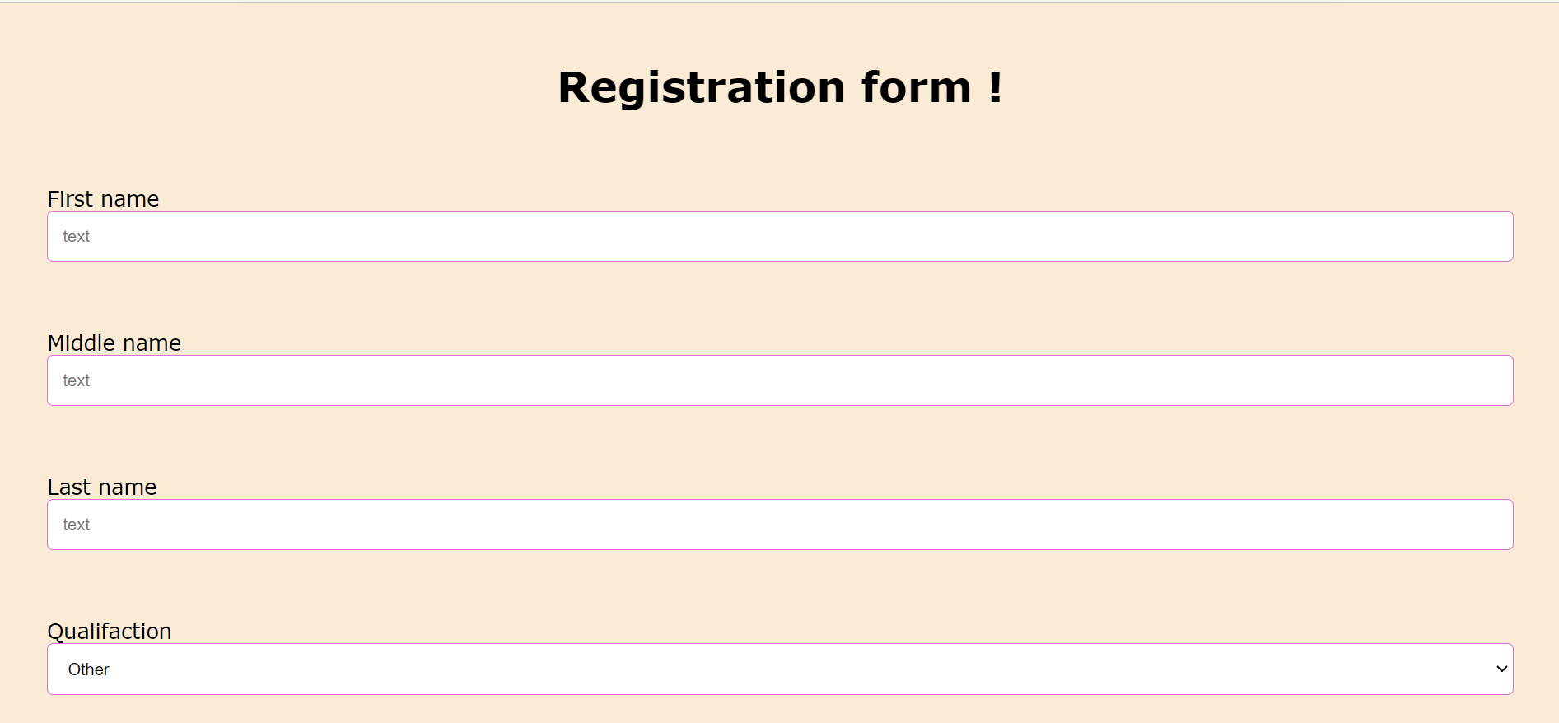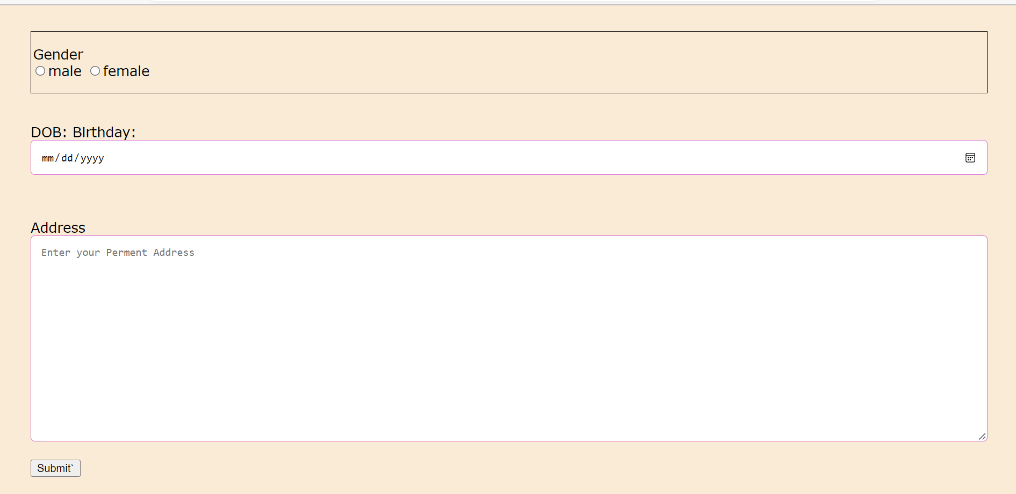

Q2.

Code:-

import java.util.*;

 public class q2 {

     public static void main(String[] args){

     Scanner in = new Scanner(System.in);

     System.out.print("Type a line or sentance: ");

     String line = in.nextLine();  // code by Anusthan Singh (20051337)

     String upper_banao = "";

       Scanner Scanline = new Scanner(line);

         while(Scanline.hasNext()) {

             String word = Scanline.next();

             upper_banao += Character.toUpperCase(word.charAt(0)) + word.substring(1) + "";

         }

      System.out.println(upper_banao);

    }

}

Output:-



Q3.

Code

import java.util.Scanner;

interface interest

{

    int r=10;    //A code by Anusthan Singh

    void FloatInterest();

}

class PersonalEmi implements interest

{

    float p;

    int n;

    float EMI;

    PersonalEmi()

    {

        Scanner s=new Scanner(System.in);

        System.out.println("Enter the principal ammount:");

        p=s.nextFloat();

        System.out.println("Enter the number of months you want:");

        n=s.nextInt();

    }

    @Override

    public void FloatInterest() {

        EMI=p*r*((1+r)^n/(1+r)^n-1);

        System.out.println("The monthly installment is"+EMI);

    }

}

class compoundI implements interest

{

    float p;

    int n;

    int t;

    float CI;

    compoundI()

    {

        Scanner s=new Scanner(System.in);

        System.out.println("Enter the principal ammount:");

        p=s.nextFloat();

        System.out.println("Enter the number of months the ammount is taken:");

        t=s.nextInt();

        System.out.println("Enter the number of months the ammount is componded:");

        n=s.nextInt();

    }

    @Override

    public void FloatInterest() {

        CI=p*(1+r/n)*(n*t)-p;

        System.out.println("The Compound interest would be:"+CI);

    }

}

    public class q3 {

        public static void main(String[] args) {

        PersonalEmi p=new PersonalEmi();

        p.FloatInterest();

        compoundI c=new compoundI();

        c.FloatInterest();

        }

    }

Output:-

